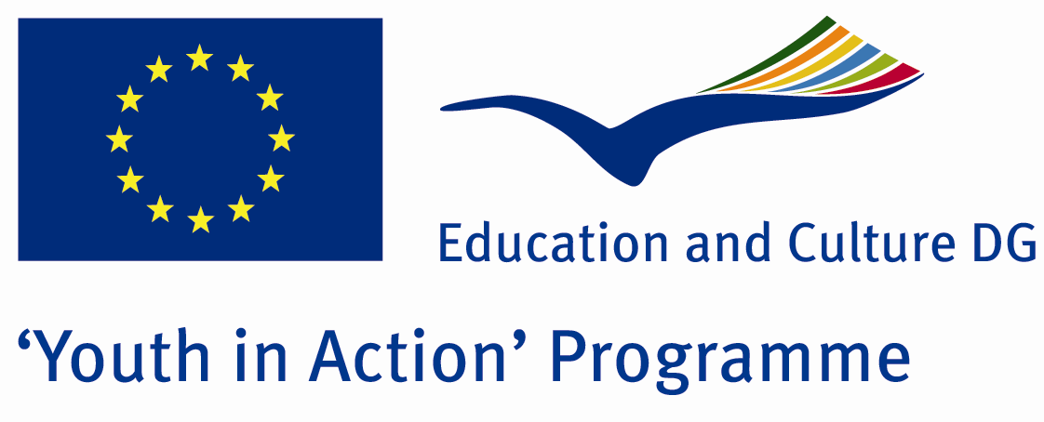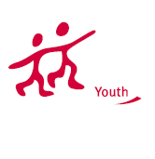

Action 4.3
Project Summary; Anatolia, where many civilizations and religions lived and live together and pray to God on the same soil. We will study the tolerance, problems and expectations of the people from different religions living together in our project.

Project Title; Bell,Ezan and Hazan
Date and Venue ; 16-22 July
Place: Mardin, Turkey.

Target Group ; Municipalities, City Councils and Non-Governmental organizations,
youth groups,culture and art groups,e.t.c

Participants ; 5 people from each country (over 18 -25 ). Totally 8 countries.

Conditions ; Accommodation, board and programme costs will be financed through European Commission Youth in Action Programme . Travel costs will be reimbursed in 70% (APEX Tarrifs). Organizations from all 27 EU member countries plus Liechtenstein , Norway and Iceland are eligible to take part.

Working language: English

Organisator group:Group Trabzan

How to apply: If you are interested, please send your Part III forms to
by e-mail please (in word file). Scan Part3 format is enough for application.(Fulfilled Part III which you can find in the attachment, of course signed and stamped) ..

Contact e-mail: grouptrabzang@gmail.com

